Dessa Shapiro

11/20/19

Counting by 7s

I am reading the book Counting by 7s by Holly Goldberg Sloan. The main character of this book is Willow. She is an adopted 12-year-old girl with an exceptional mind. Willow is a very smart girl that unlike a lot of other girls her age, likes science, math, exploring new things and making experiments. Since Willow has always been different she hasn't had many friends. She finds it hard to connect with people, and find people with similar interests and have the same mindset. In the book Willow is started middle school and has decided to move to a new school, to have a fresh start and make new friends.

When Willow first starts school, she starts to realize that no one is like her, and she isn't passionate about the same things of kids her age. Willow finds classes boring because she already knows the information, she starts to fit into an unhealthy runtime. When her class starts taking standardized tests she gets a perfect score. The next day she was called into the principal's office and accused of cheating, not defending herself she was sent to the counselor. The school counselor is called Dell Duke and did not originally want to be a counselor or be anything related to psychology. Therefore he is always very bored with his job. When he meets willow he started to realize that not all people can be placed into special categories.

“ And for the first time in his professional career, he was not just motivated. He was almost inspired. The counselor had to add a new group to his system…Because Dell Duke believed he had discovered a new category of the strange: GENIUS.”(Pg. 61) I think that this passage resonates with me because I have been put into a category before, but I have felt that I have never really belonged in just one category. When I was in 6th grade I was just starting a new school and I didn’t know where I fit in. I had an old group of friends that I didn’t feel I belonged with anymore. All I saw were a lot of groups, each with different special interests, I saw the popular kids, the drama kids, the art kids, and many other groups. I remember thinking to myself that since I didn't share any of these interests I didn’t fit in. But as I got to know people the more different things I see in them. I realized that there are not categories that make groups, and that all the people, their personalities and different interests make a group. As soon as I had this realization I found my group in no time, and everything seemed more clear. I think that I can empathize with how willow must feel when she can’t find her place and doesn't feel she fits in. I can also understand how Dell Duck views people because at first he has a very narrow sight and can only see one type of kid. When he meets willow his eyes open and he can see different types of people.

I also like this passage because I feel the author expresses how the character an evolving. In this short passage you can see that the author used a lot of descriptive words to express and exaggerate how the character, Dell Duke is coming to a realization. You can also find a lot of different writing techniques used throughout the book. The author uses a lot of listing in the book to clarify how intelligent Willow is. I also find it very interesting how factual the book is. There is not a lot of emotional scenes in the book, so when there is it has a bigger impact.

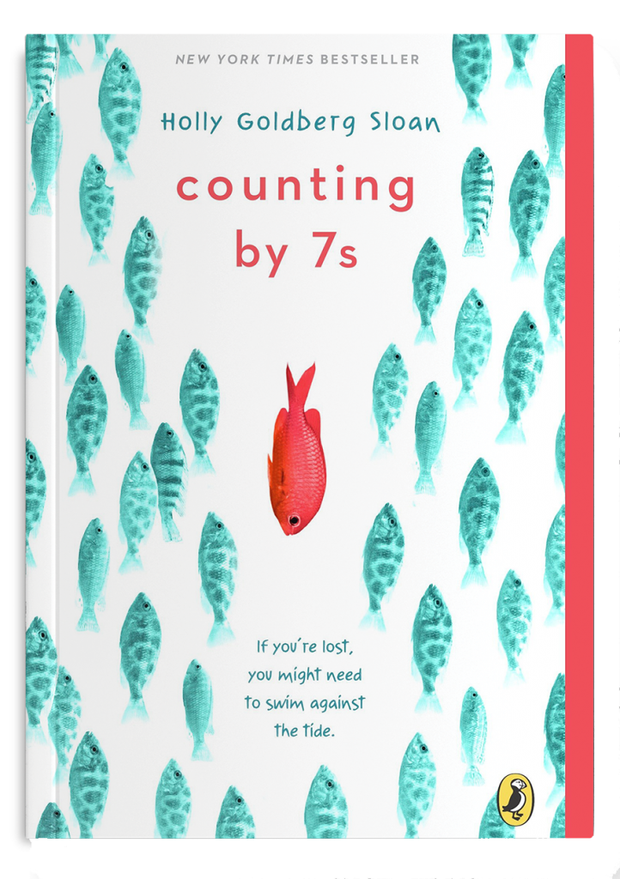

This is a picture of part of the book cover and I think it shows that some people are different, and seem to be going in a totally different direction.

**Alessia Cara - Scars To Your Beautiful**

I chose this song because I think it explains that someone can become lonely and feel horrible when they don’t fit in or feel different.